CRM APPLICATION FOR JEWEL

MANAGEMENT DEVELOPER

**College Name: SRI KRISHNA ADITHYA COLLEGE OF ARTS AND SCIENCE**

**College Code:**

**TEAM ID:**

**TEAM MEMBERS:**

**Team Leader Name:** JENIFA S

**Email:** [23bsai222jenifas@skacas.ac.in](mailto:23bsai222jenifas@skacas.ac.in)

**Team Member1:** MUKESH P

**Email:** [23bsai236mukeshp@skacas.ac.in](mailto:23bsai236mukeshp@skacas.ac.in)

**Team Member2:** MIRTHUNA SRI B

**Email:** [23bsai229mirthunasrib@skacas.ac.in](mailto:23bsai229mirthunasrib@skacas.ac.in)

**Team Member3:** NAVEEDH KHAN N

**Email:** [23bsai238naveedhkann@skacas.ac.in](mailto:23bsai238naveedhkann@skacas.ac.in)

**Salesforce**

1. **Creating Developer Account**
2. **Account Activation**

**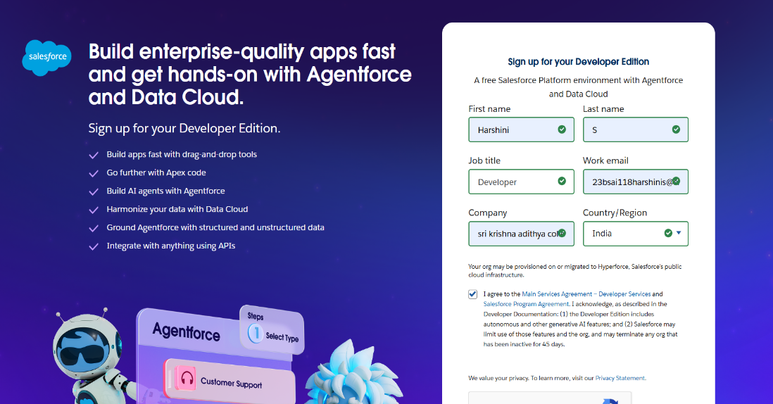  
  
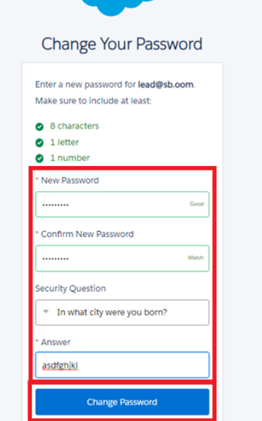**

**Object**

**1.Create Jewel Customer Object**

**2.Create item object**

**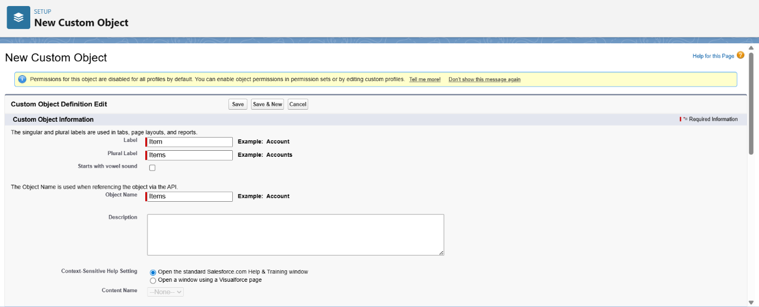  
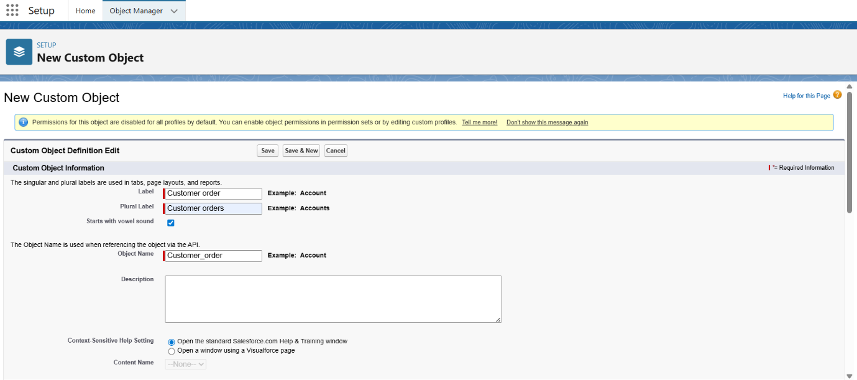**

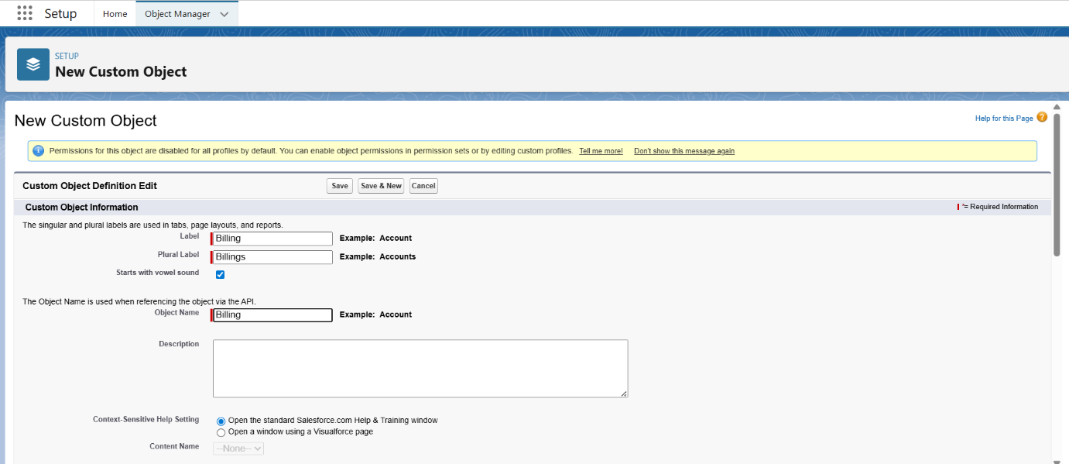

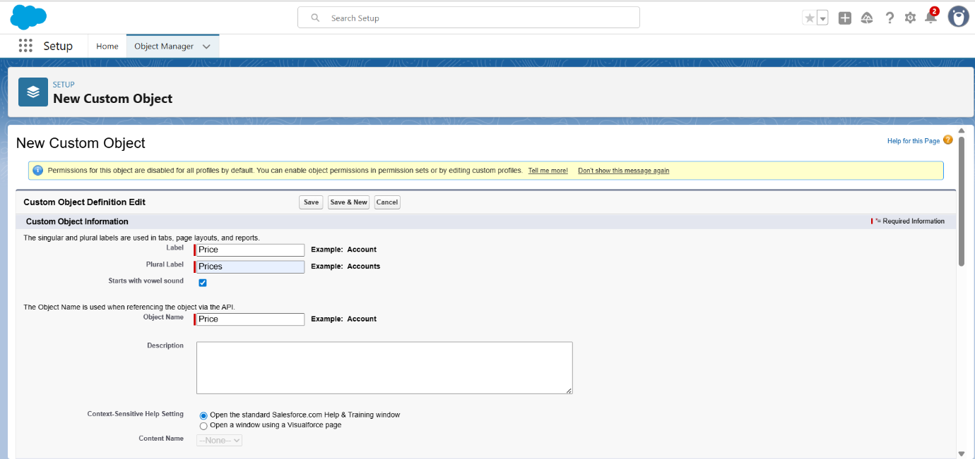

**Tabs**

1. **Creating a custom tab**
2. **To create a tab: (Item)**

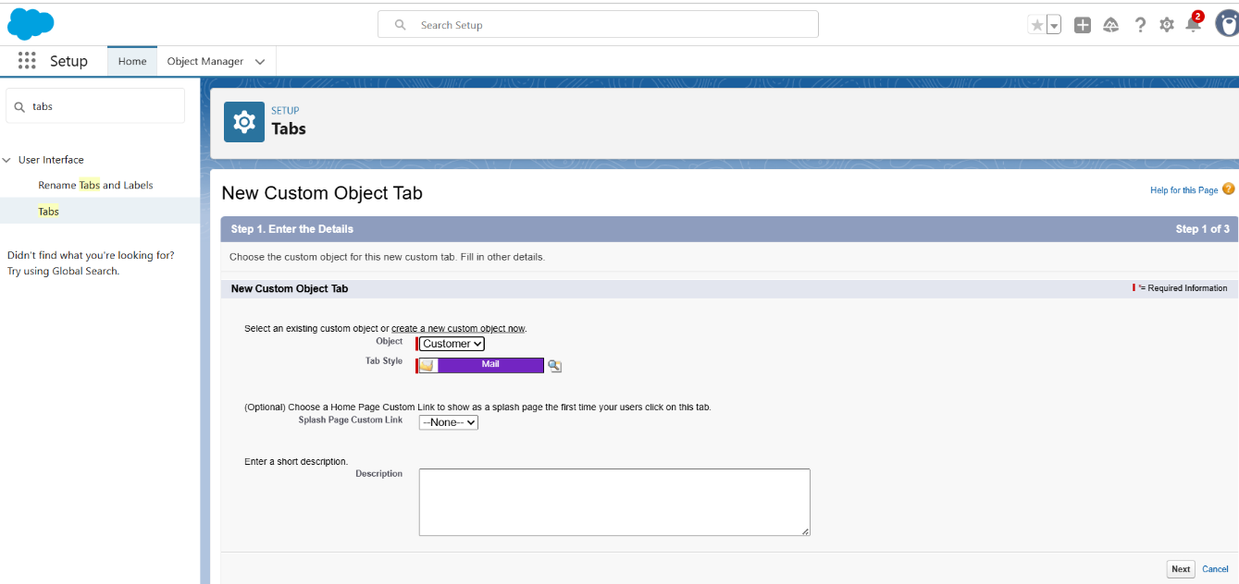

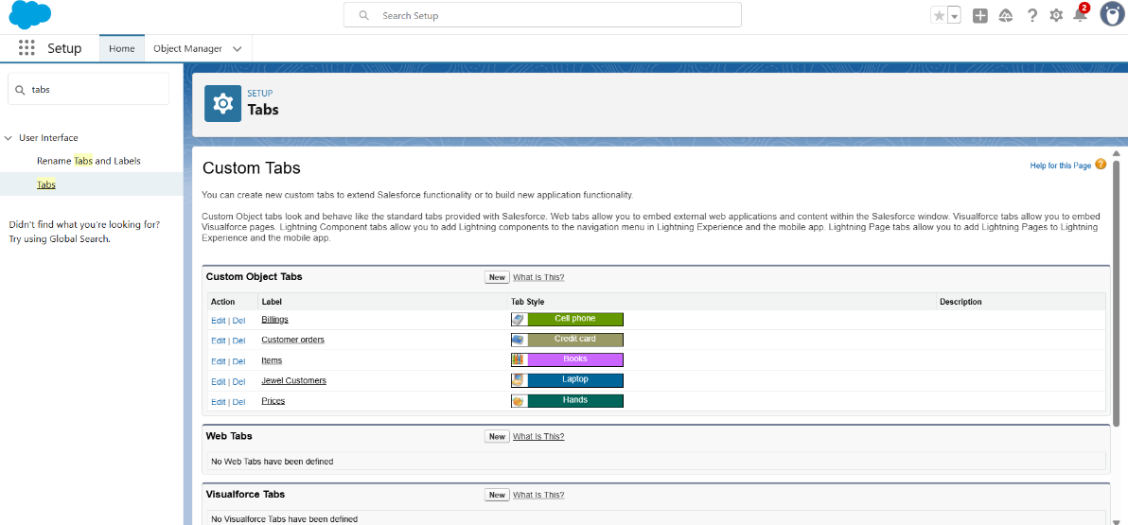

**Lightening App**

1. **Create a lightening app**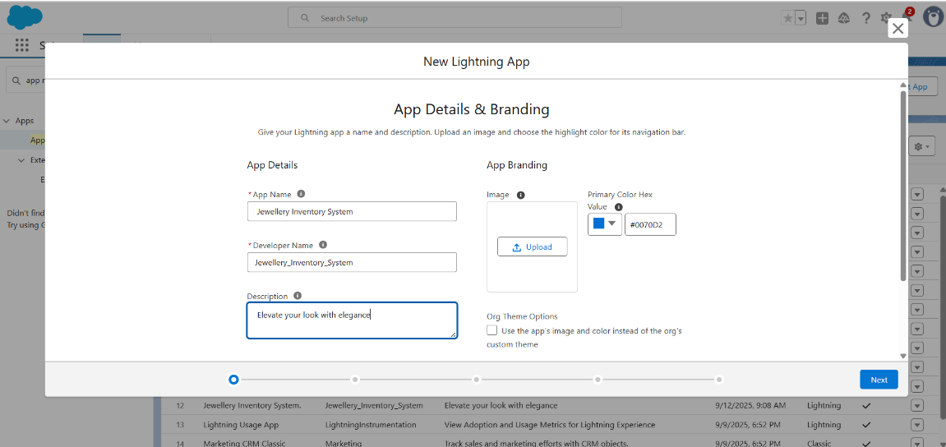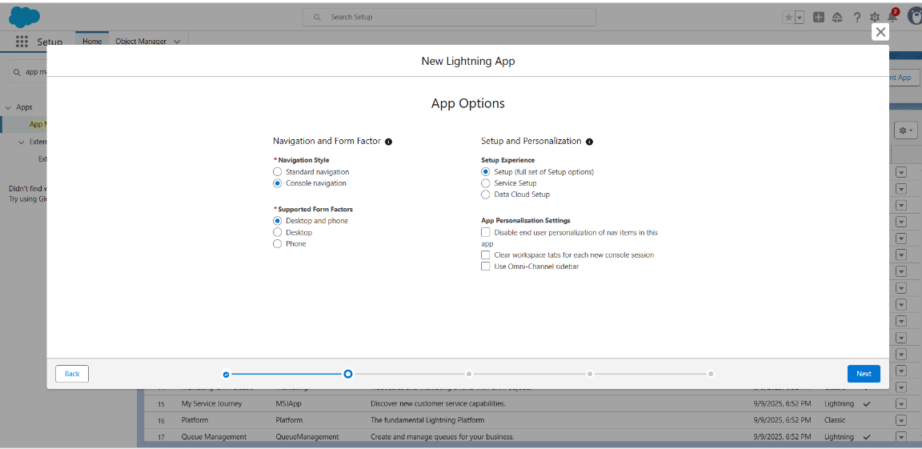

**Fields**

1. **Creating lookup Relationship**

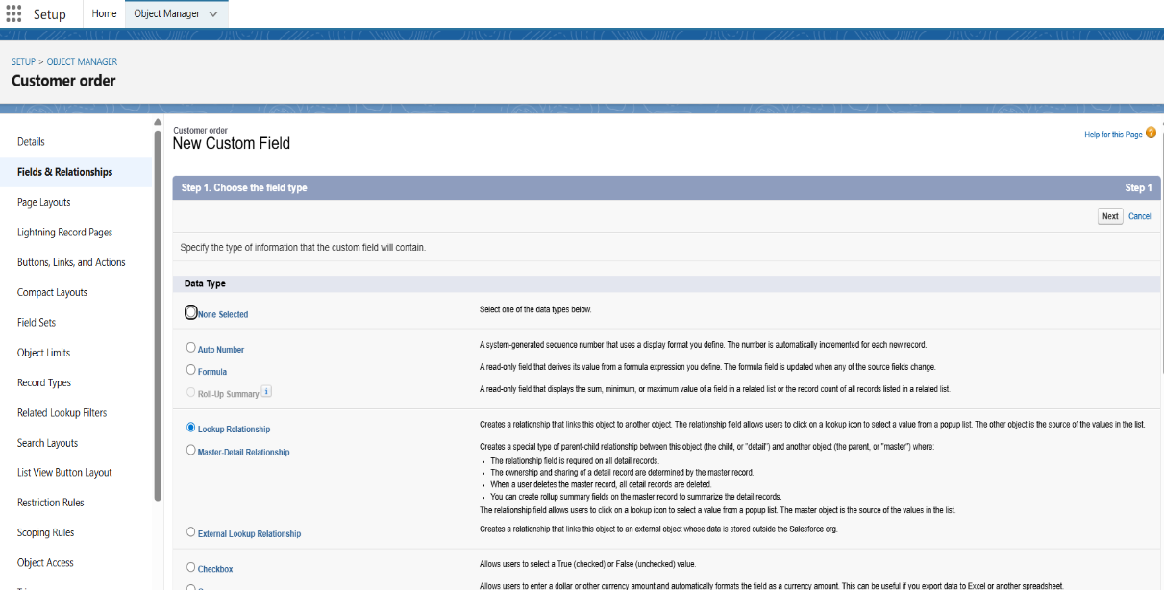

1. **Create a master detail relationship**

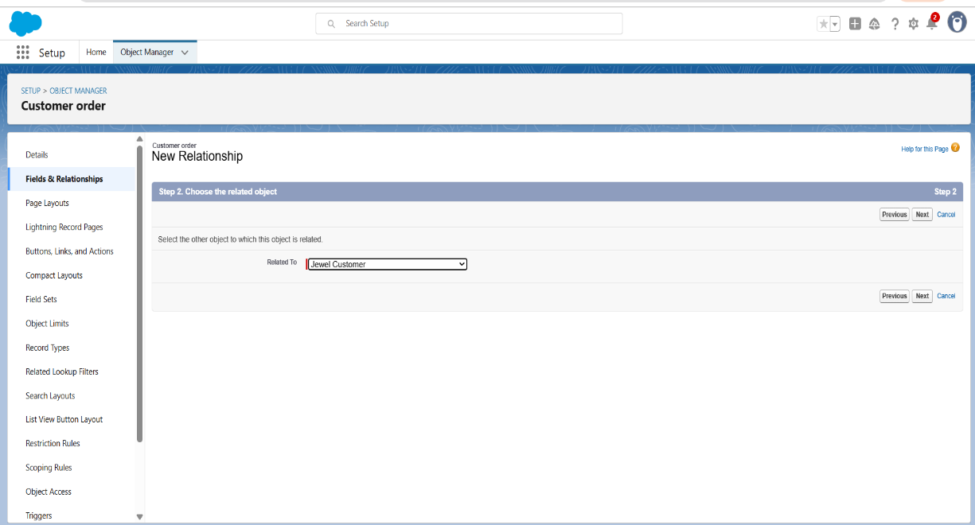

1. **Creating a text field in jewel customer object** 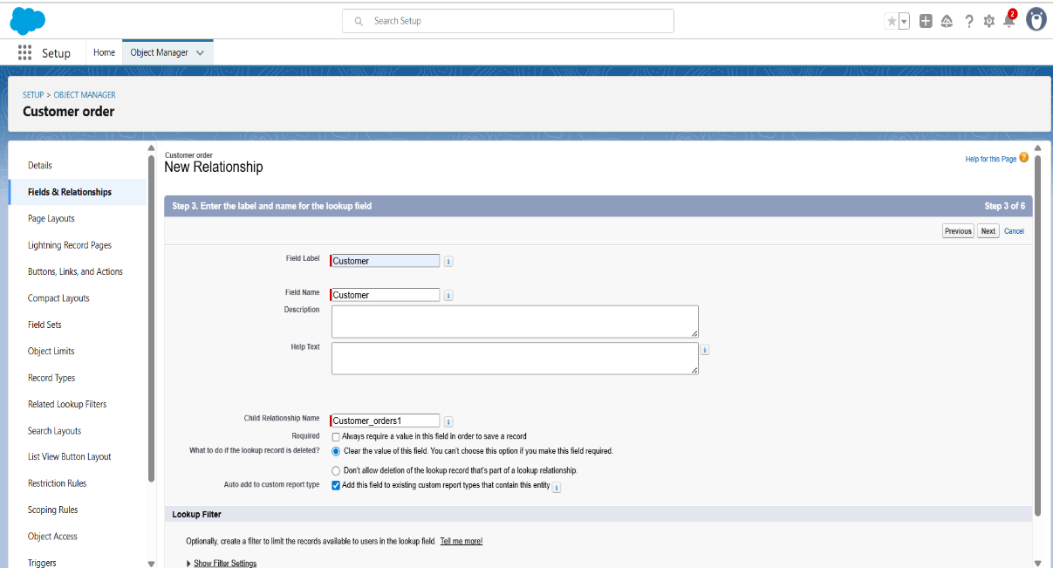
2. **Creating the phone field in object jewel customer**

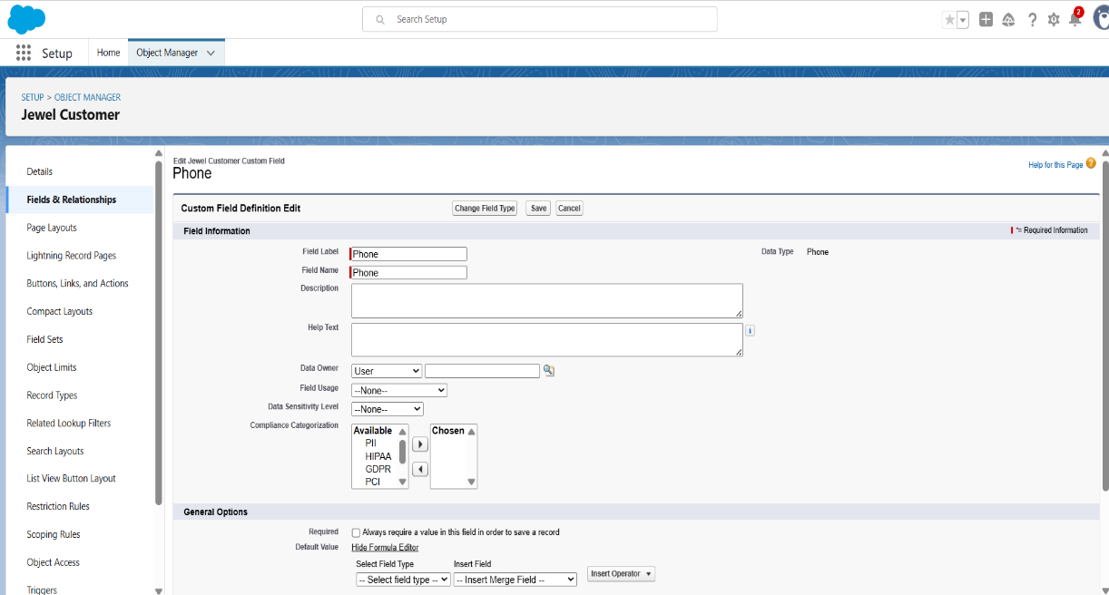

1. **Create the Email Field in object jewel customer**

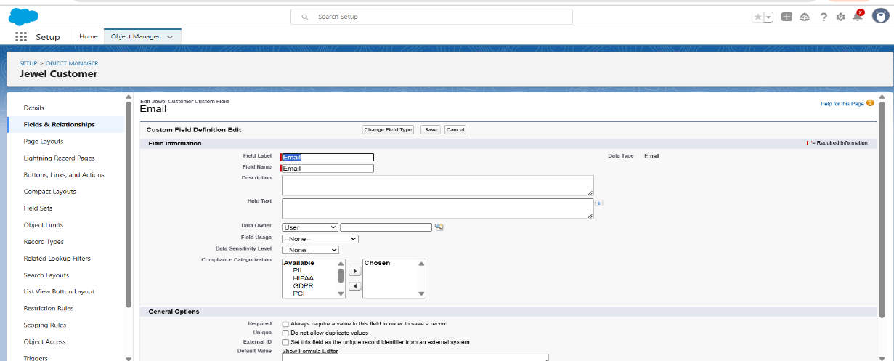

1. **Creating the number field in item object**

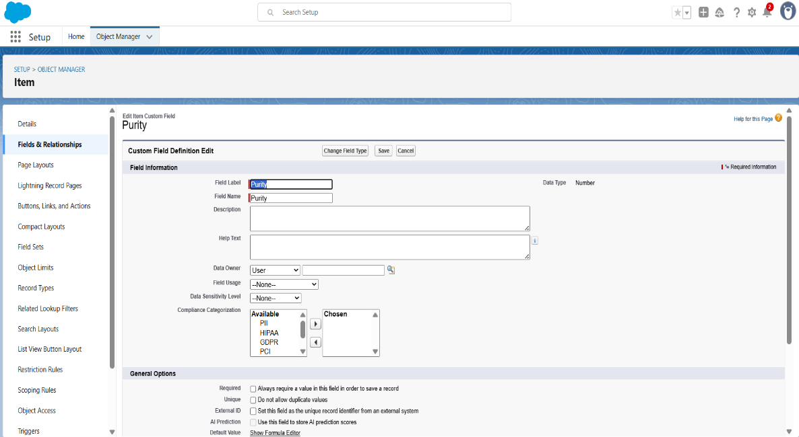

**7.Creating picklist field in Item Object**

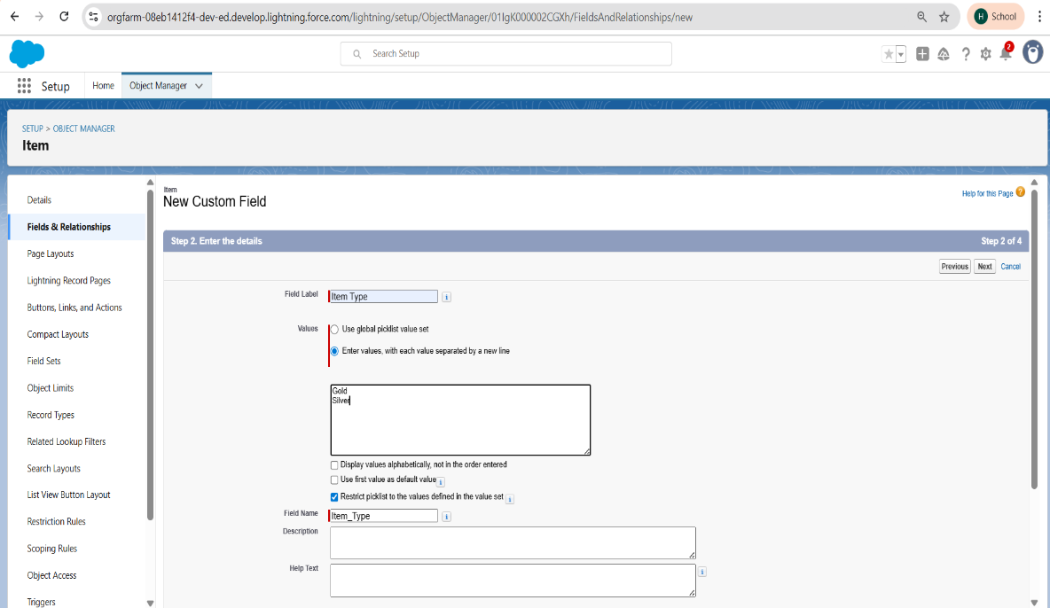

**8.Creating currency field in price object**

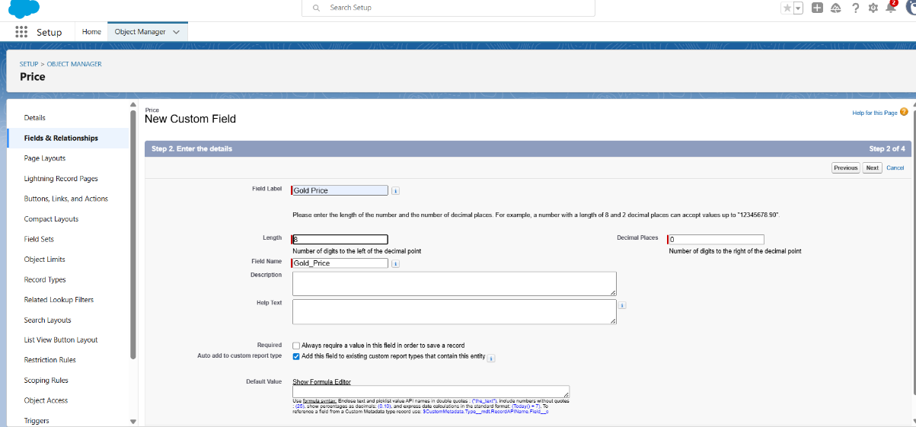

**9. Creating Formula field in item object**

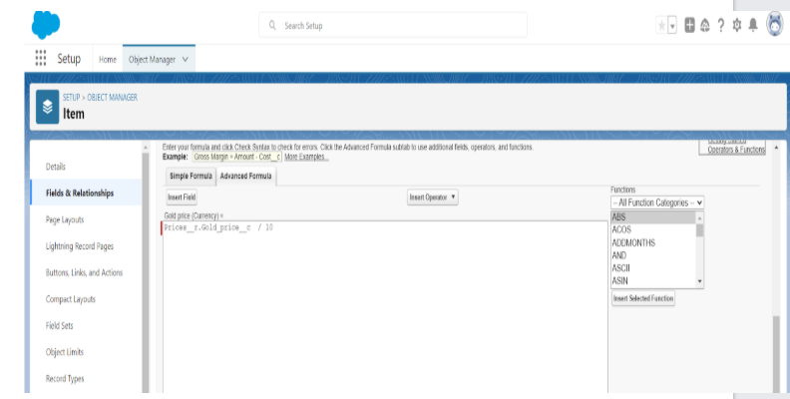

**10.Creating the field dependencies** 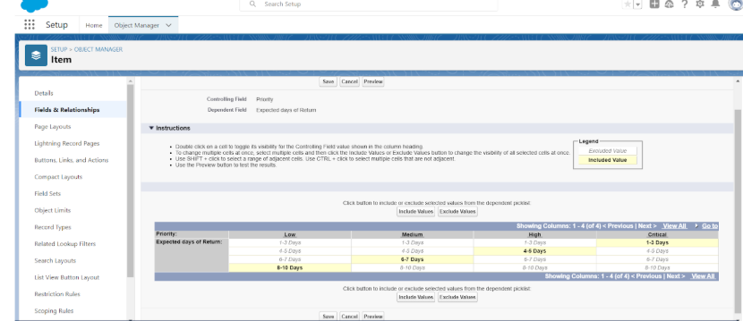

**11.Creating the validation rule**

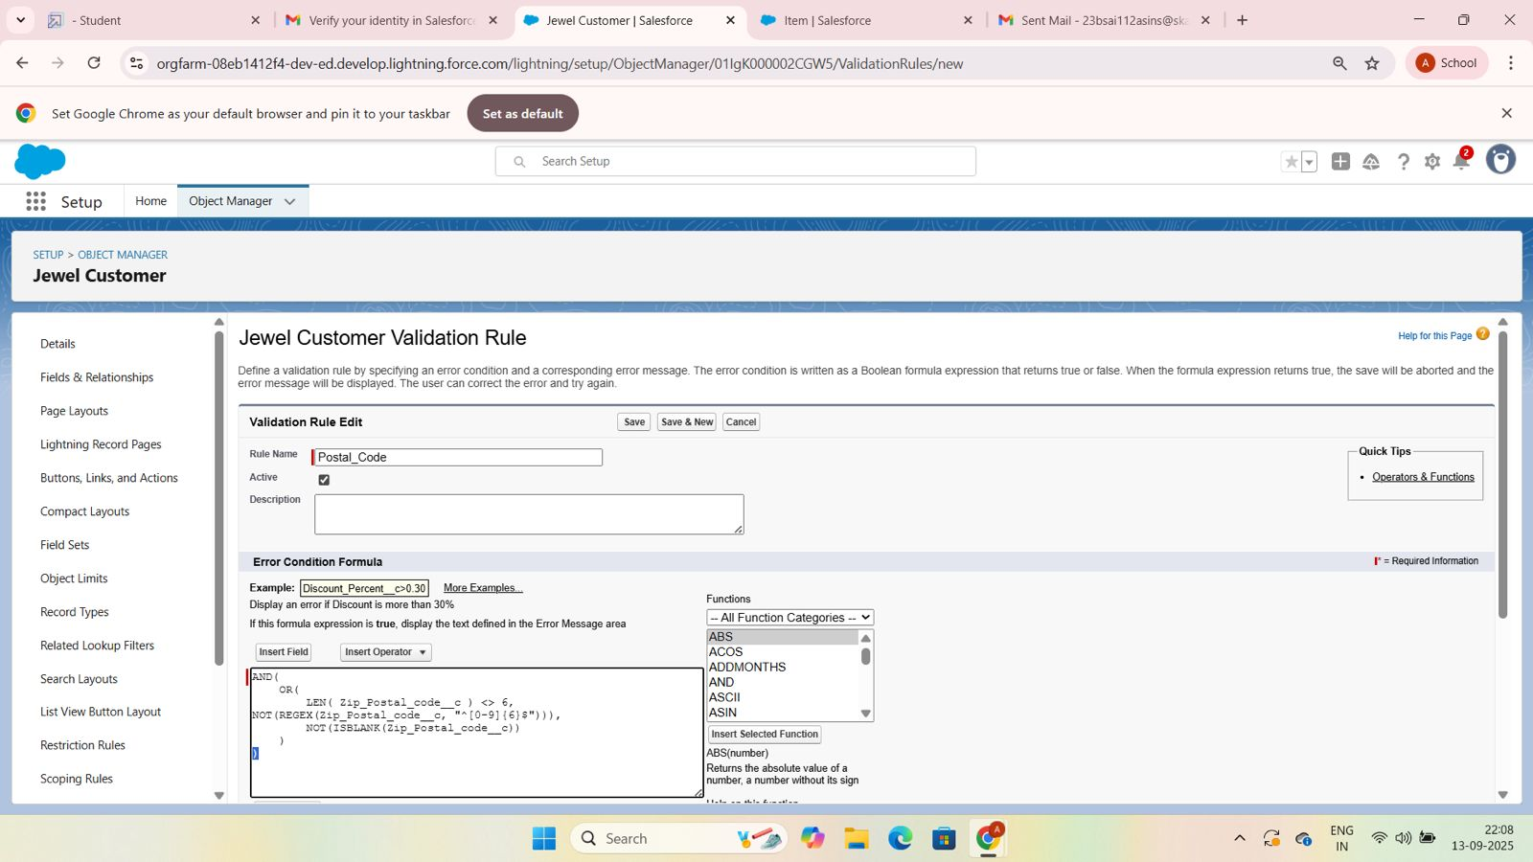

**Profiles**

1. **Gold smith profile**

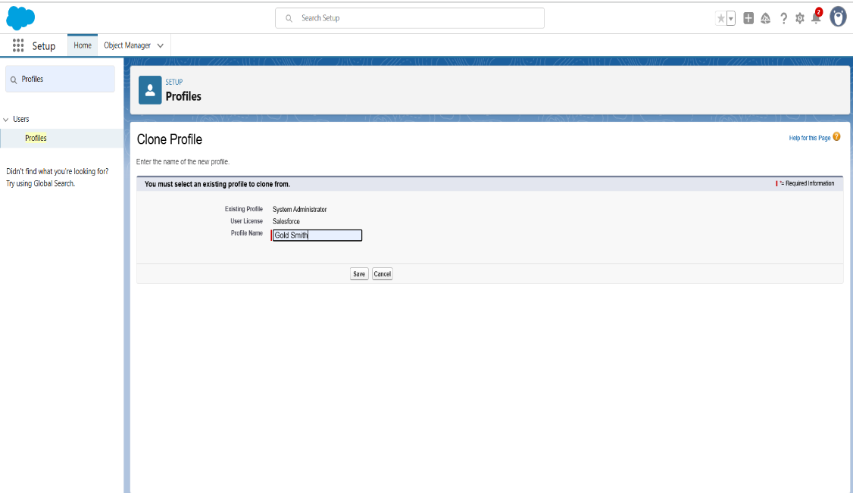

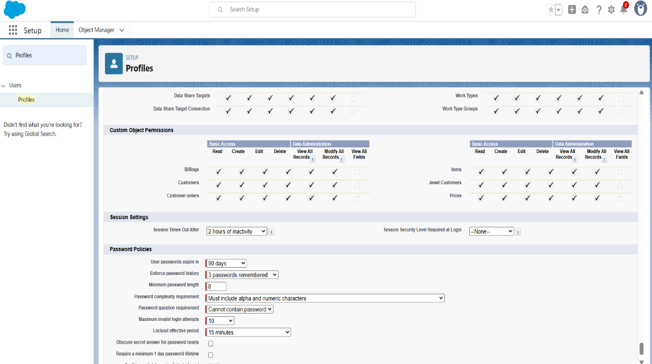

1. **Worker profile**

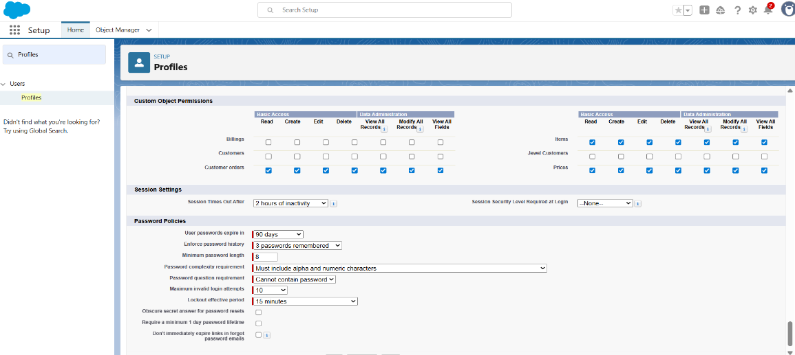

**Roles**

1. **Creating Gold smith role**

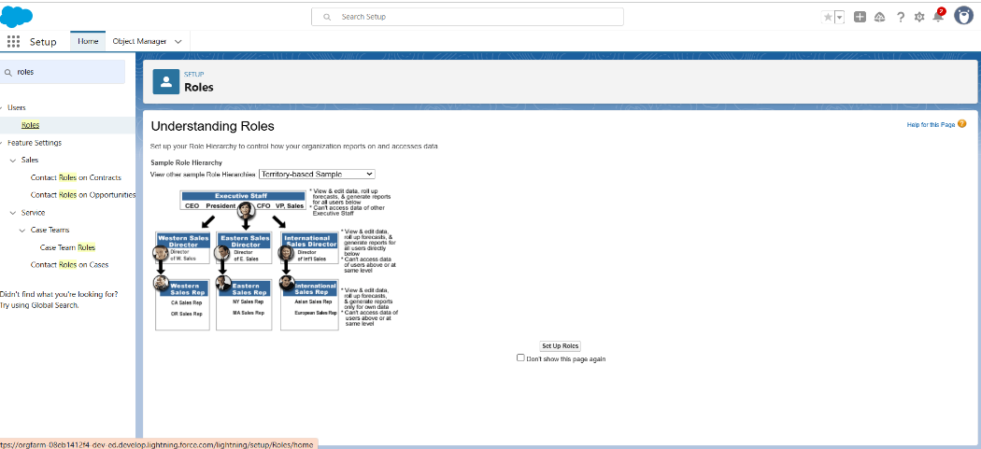

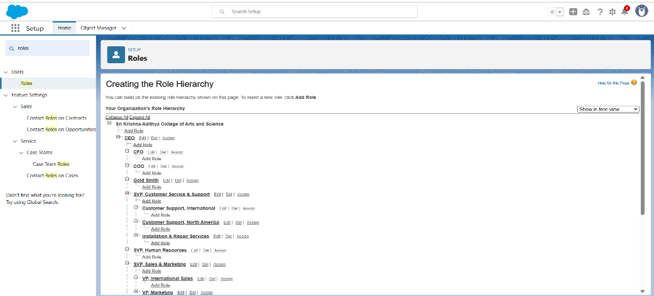

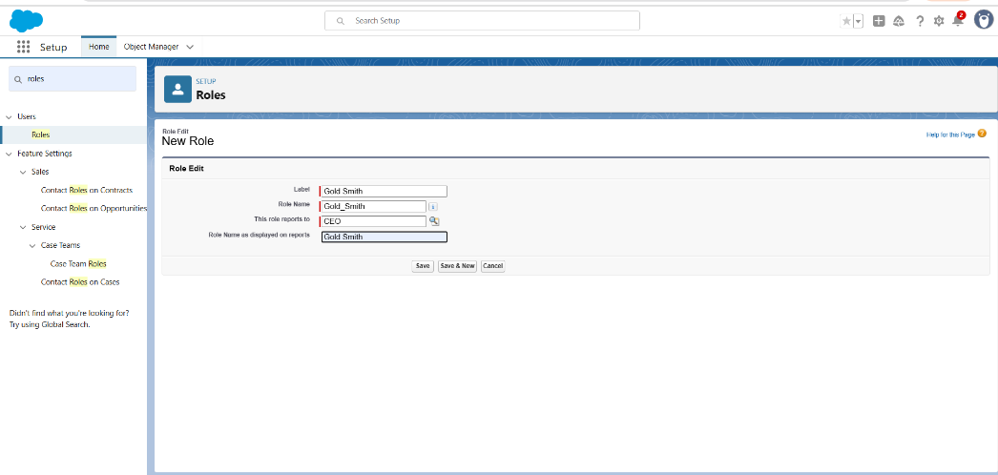

1. **Create one more role as worker which reports to gold smith**

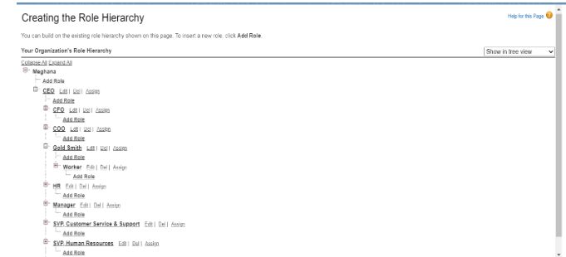

**Users**

1. **Create user**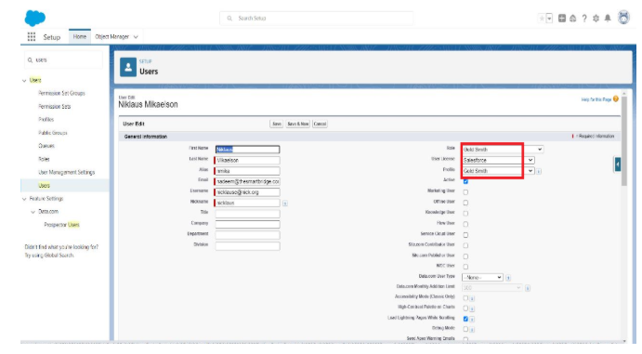

**2.Create user**

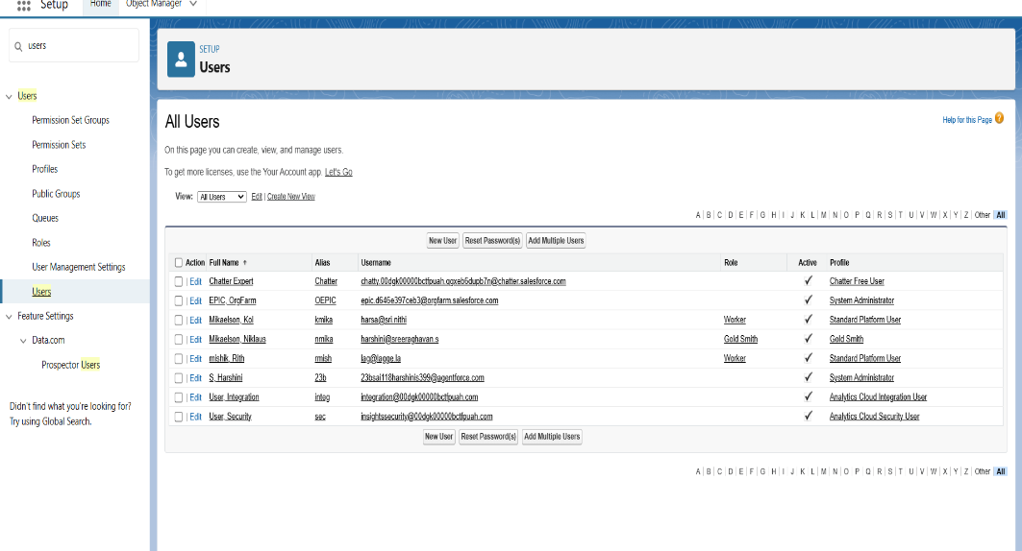

**Page layouts**

1. **To create a gold page layout**

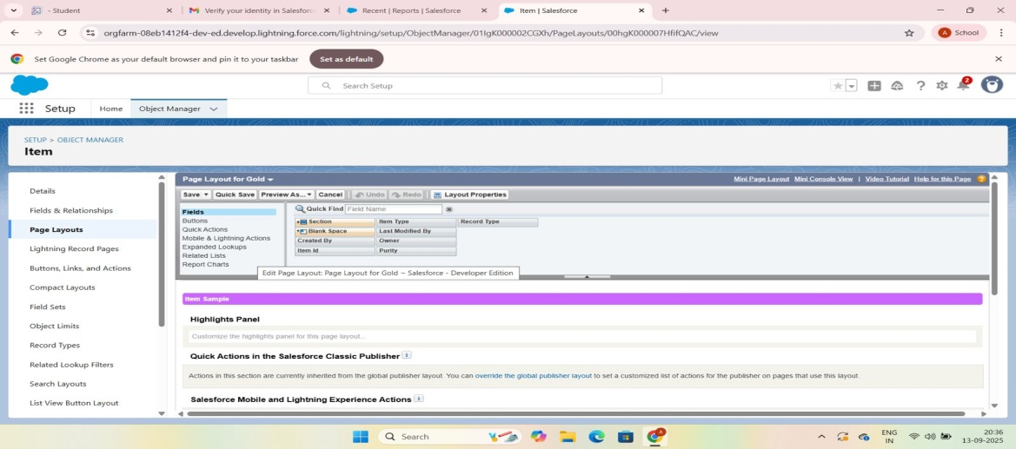

1. **To create a silver Page layout**

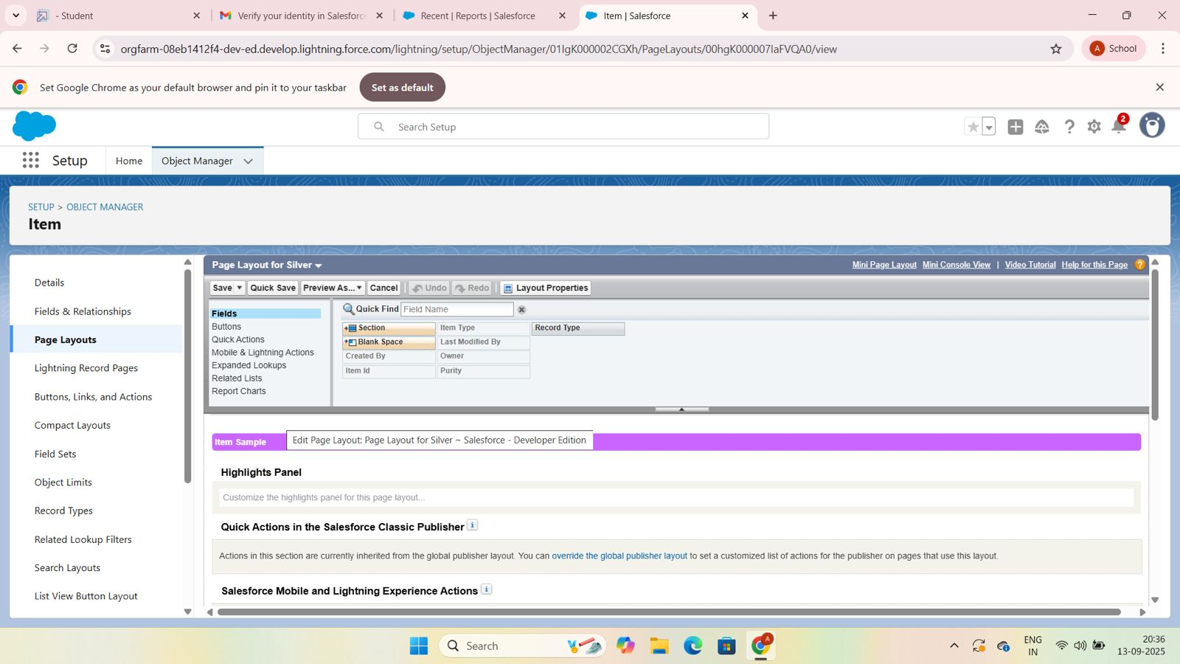

**Record types**

1. **To create a Record type**

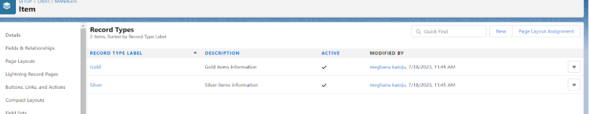

**Permission sets**

1. **Creating a permission set**

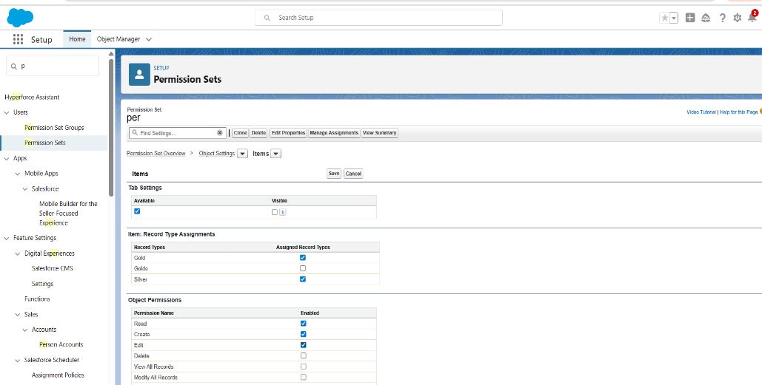

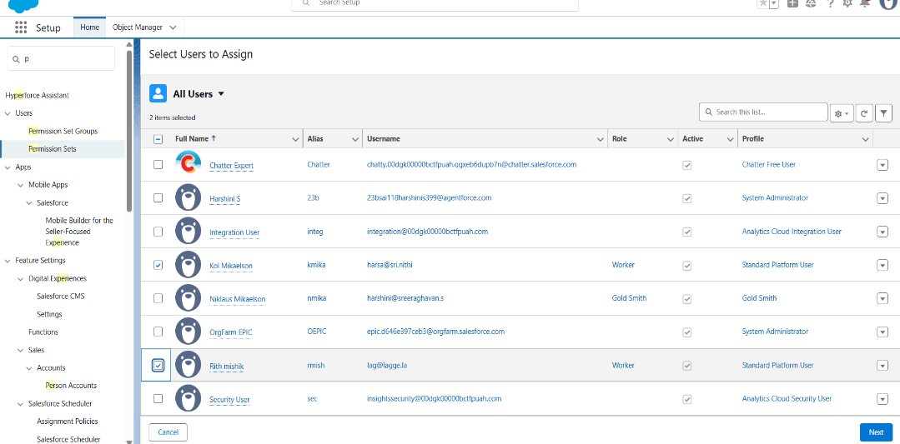

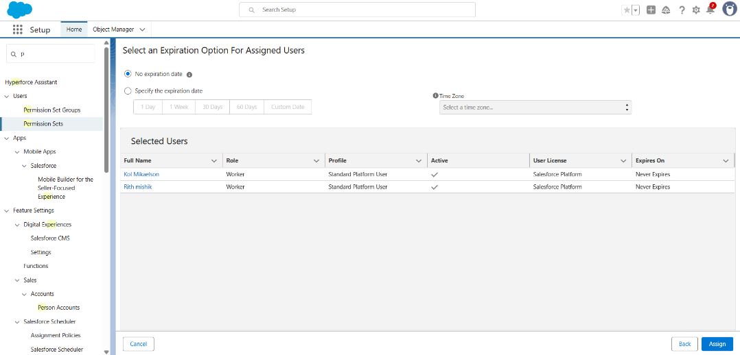

**Trigger**

**1.Create a trigger handler class**

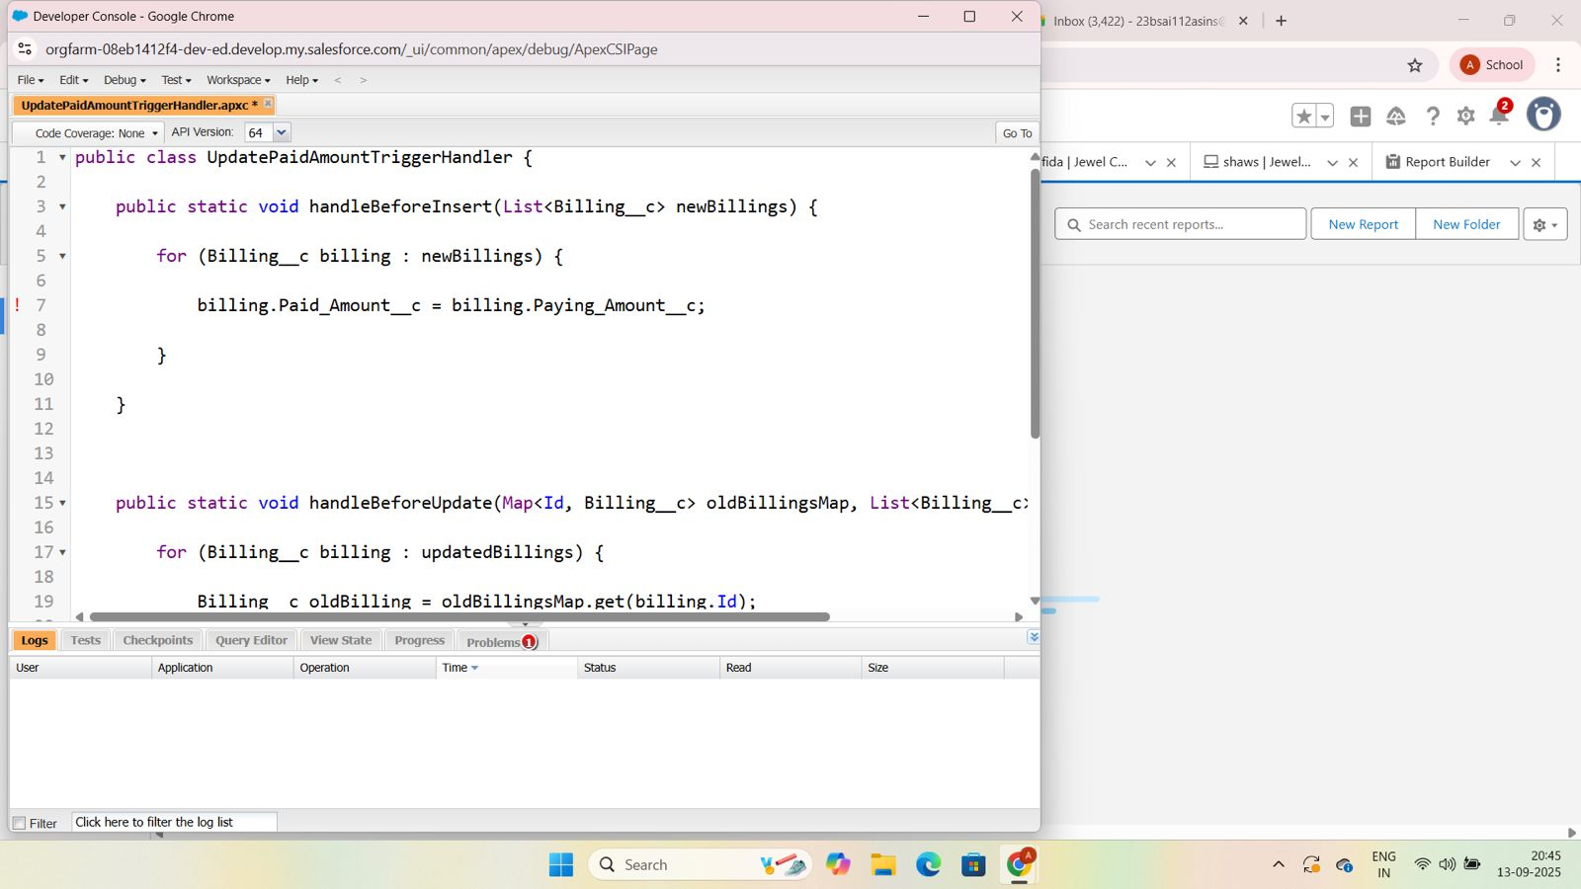

**2.Create the trigger**

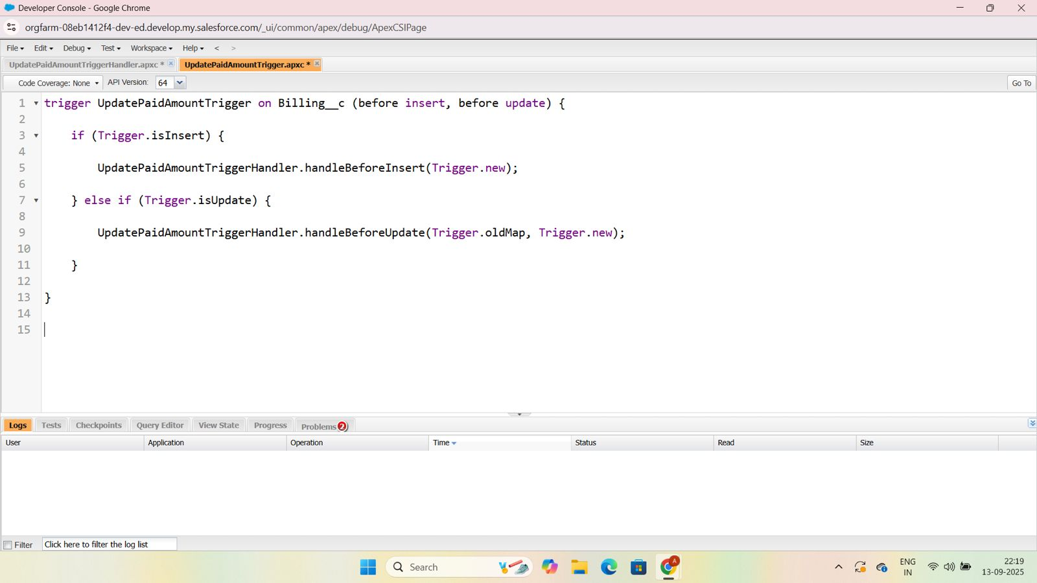

**User Adoption**

**1.Create a record(jewel customer)**

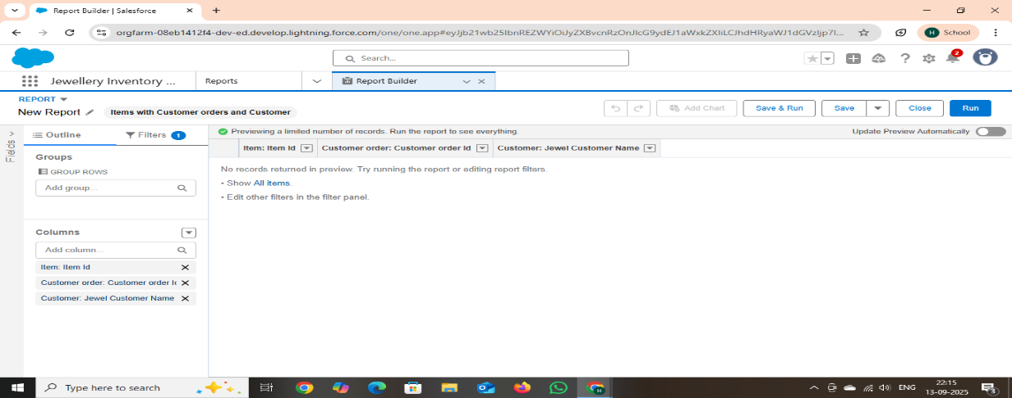

**2.View a record(jewel customer)**

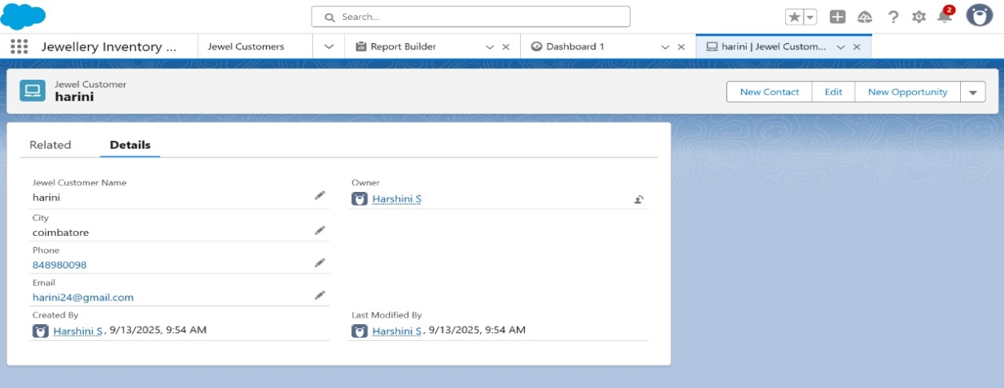

**3.Delete a record(jewel customer)**

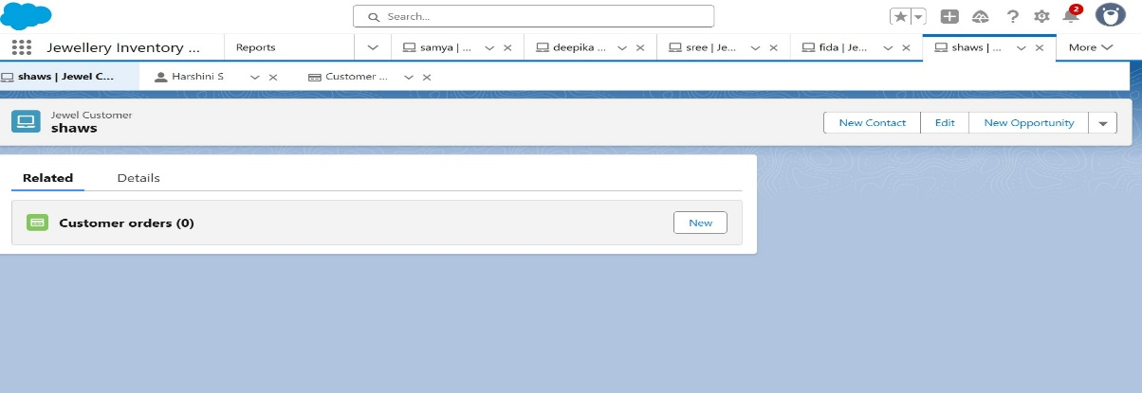

**Reports**

1. **Create Report**

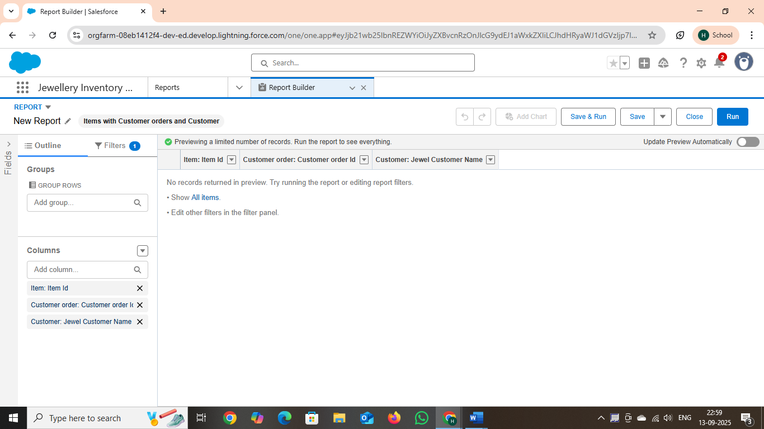

**Dashboards**

**1.Create a dashboard**

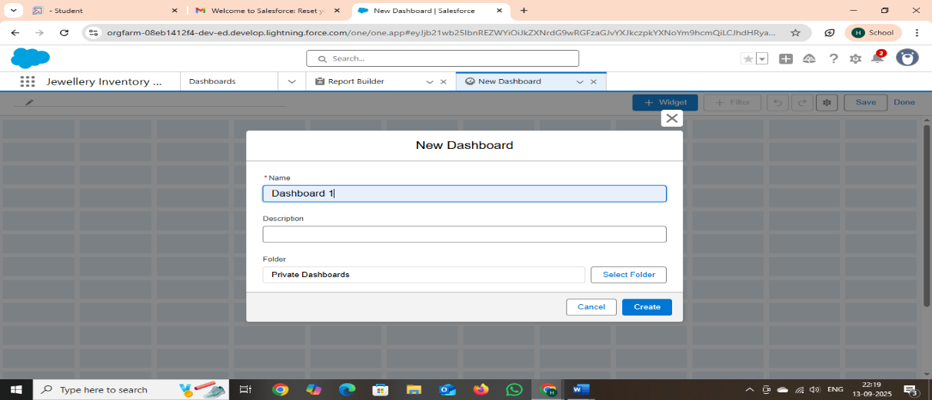

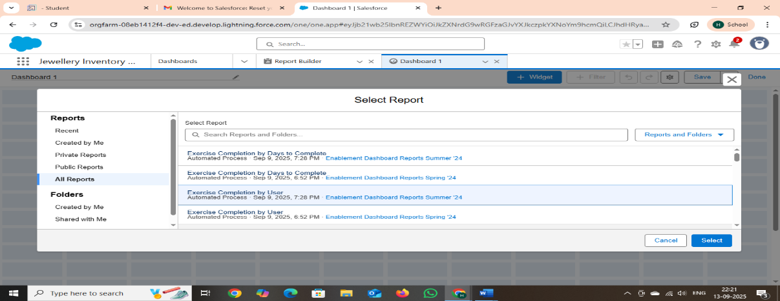

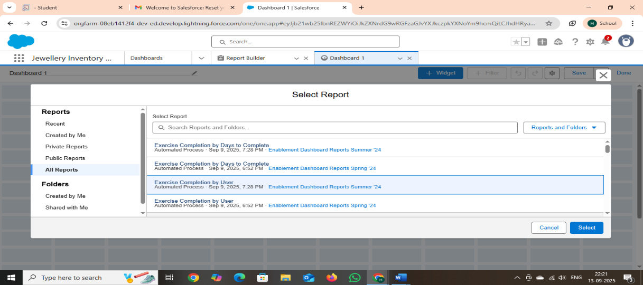

**Flows**

**1.Create a flow**

